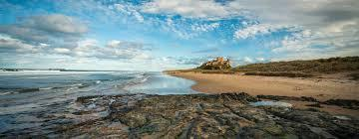

The Coastal Society’s 2024 Annual Member Meeting (Virtual)

July 10, 2025

12 PM – 1:30 PM (EDT)

11 AM - 12:30 PM (CDT)

9 AM - 11:30 AM (PDT)

15 min Welcome and Introductions

Approval of 2024 Annual Meeting Minutes

2024 Annual Report Highlights

10 mins Regional Forum, October 24, 2025, Wilmington, NC

25 mins Committee/Programming Highlights

* Chapters
* Coastal Connections Series
* Communications
* DEIA Working Group
* Development
* MAD Career Workshops

10 mins Student Chapter Highlights

* Duke University
* East Carolina
* URI
* UNCW

10 mins Member Roundtable

15 mins 2024 Awards

5 mins Thoughts and Adjourn