In partnership with the Atlantic Estuarine Research Society
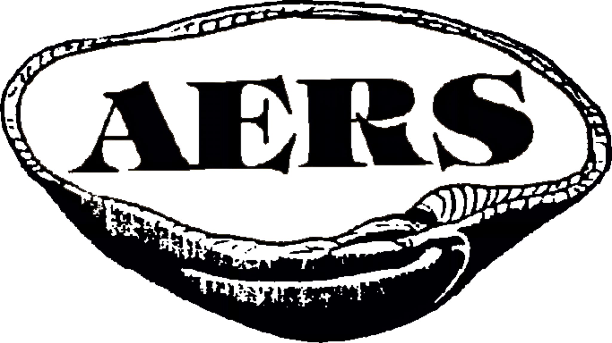
Presents
The Margaret A. Davidson Coastal Career Workshop
March 21, 2024 · 12:00pm-5:00pm
VIMS Gloucester Campus - Davis Hall (7539 Spencer Rd, Gloucester Point, VA 23062)
Agenda
12:00pm Lunch (Provided) & Networking
1:00pm Welcome & Margaret’s Legacy
1:10pm Panel 1: Coastal Career Path Options
- 1:15pm Dr. Treda Grayson, EPA - Federal Government
- 1:25pm Curt Smith, MPPDC - Regional Government
- 1:35pm Jessica Steelman, Steelman Coastal Consulting - Regional Government to Consulting
- 1:45pm Mary-Carson Stiff, Wetlands Watch - NGOs & Resilience
- 1:55pm Q&A
2:05pm 5 Min Break
2:10pm Lightning Round 1: Networking, Marketing Yourself, & Transferable Skills
- 2:15pm Cirse Gonzalez, CBNERR - Marketing Yourself
- 2:20pm Erin Reilly, CBNERR - Transferable Skills
- 2:25pm Jeff Flood, Virginia CZM - Networking Never Stops
2:30pm Transition to Breakout Groups
2:40pm Breakout Session 1 (Speakers Rotate Through 3 Groups @ 15 min Each)
3:25pm Transition to Main Room
3:35pm Lightning Round 2: USAJobs, Community Outreach, & Consulting
- 3:40pm Carolyn Iwicki, Ph.D. Candidate - Rutgers University - USAJobs 101
- 3:45pm Cam Bruce, Nansemond Indian Nation - Community & Tribal Engagement
- 3:50pm Ashley Gordon, Dewberry - Resilience Opportunities in Consulting
3:55pm Transition to Breakout Groups
4:00pm Breakout Session 2 (Speakers Rotate Through 3 Groups at 15 min Each)
4:45pm 5 min Break
4:50pm Wrap Up/Next Steps
5:00pm Optional Tour of Acuff Center for Aquaculture
6:00pm Optional AERS HH in Davis Hall (~$20 tickets available for purchase from AERS at event)
Questions?
Please contact TCS Workshop Planning Team Lead Jeff Flood (jflood@udel.edu)
See reverse side for workshop & parking locations.
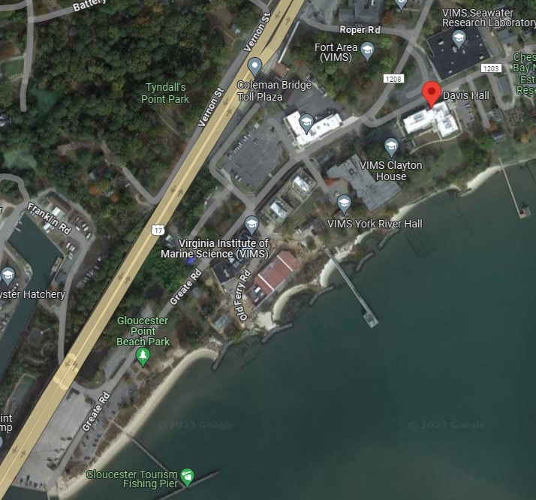
The workshop is being held in Davis Hall (7539 Spencer Rd, Gloucester Point, VA 23062) on VIMS’ Gloucester Point campus. Free parking is available in the Gloucester Point Beach Park (bottom left of the above screen capture). Once parked, please walk up the hill along Greate Road then take a slight right onto Spencer Road (the triangular parking lot will be to your left). TCS & AERS workshop staff will be outside Davis Hall to direct you inside. Please note: if you plan to cross the Coleman Bridge (U.S. Route 17) from the south, please be prepared to use an EZ Pass or pay $2.00 cash at the toll plaza on the Gloucester side.

