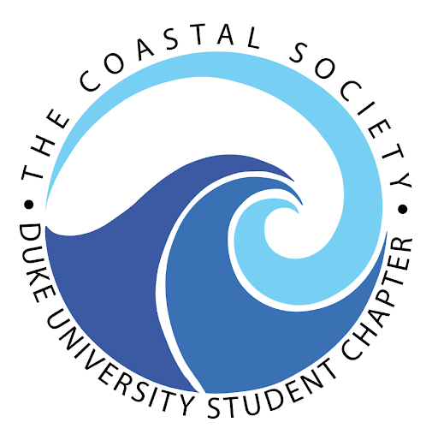
Margaret A. Davidson Career and
Professional Development Workshop

Hosted by Duke University Student Chapter
December 3, 2021
Zoom

10:30 – 10:45 am Welcome

10:45 – 12:00 pm Opening Plenary Panel: Navigating Through Your Career
- Sloan Freeman, Director of Hydrospatial Operations, Geodynamics
- Charlotte Hudson, Project Director, Lenfest Ocean Program, The Pew Charitable Trusts
- Andrew Lewin, CEO, Speak Up for the Blue Media and Communications

12:00 – 1:00 pm Lunch Break

1:00 - 1:15 pm Welcome Back & Housekeeping

1:15 – 2:00 pm Skill-Building Session 1 (participants chose 1)
- Maggie Caldwell, National Communications Strategist for the Lands, Wildlife and Oceans Program, Earthjustice
  - Session Topic: Building an Advocacy Communications Campaign: Offshore Drilling in the Gulf of Mexico
- Cirse Gonzalez, Coastal Training Program Coordinator, Chesapeake Bay National Estuarine Research Reserve
  - Session Topic: Cultural Communications
- Ali Jennings, Science Communicator and Journalist
  - Session Topic: How to Tell a Sci-Comm Story*
*come prepared with a science-communication story to tell!

2:00 - 2:15 pm Break

2:15 – 3:00 pm Skill-Building Session 2 (participants chose 1)
- Angelo Villagomez, Senior Fellow, Center for American Progress
  - Session Topic: How to Write an Effective Advocacy Letter
- Jesko von Windheim, Professor of the Practice, Innovation & Entrepreneurship, Duke University, Nicholas School of the Environment
  - Session Topic: Positioning Yourself for the Big Interview*
*download this Excel sheet for the activity

3:00 – 3:45 pm Share & Swap Break-out Groups

3:45 – 4:00 pm Closing Thoughts & Adjourn

